MediumCollar1 Assembly Guide

# Parts list

1. Type C Case x1
2. Type C Lid x1
3. MC1 PCB x1
4. LS14500 Battery x1
5. Magnet x1
6. Plastite Screws CSK x5
7. Loctite SL 596
8. IPA/degreasing solvent

Note on Loctite SL596-

*The sealant cures on exposure to atmospheric moisture, and can cure up to 6mm thick. It’s best applied in a thin, uniform and continuous bead around 1mm thick in dia.*

# Assembly steps-

1. **Ensure part quality**- Check for any loose strands of plastic, debris, cracks or irregularities in 3D printed parts.
2. **Tape magnet** into place at the far end of the case to disconnect the battery reed switch once the electronics have been inserted into the case.
3. **Solder battery connections**- Solder the battery connections to the MC1 PCB and ensure antenna wire is soldered firmly.
4. **Ensure fit**- Slide MC1 & Battery into the case. Fit should be snug with a little wiggle room. EVA foam or folded cardboard can be used to stop rattling.
5. 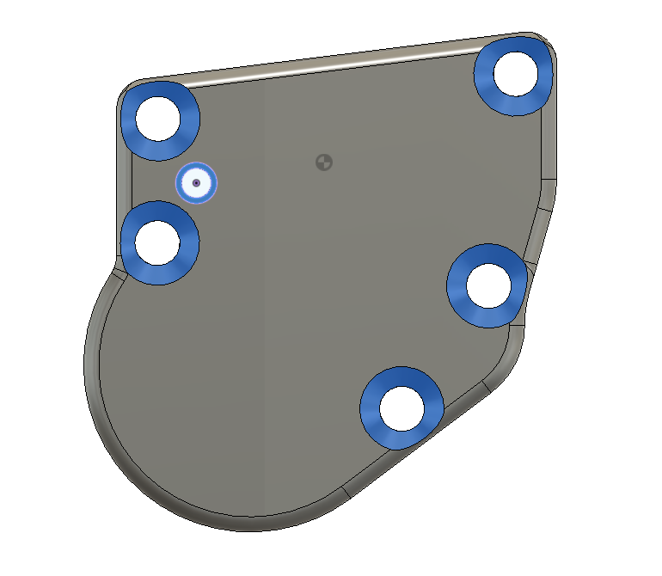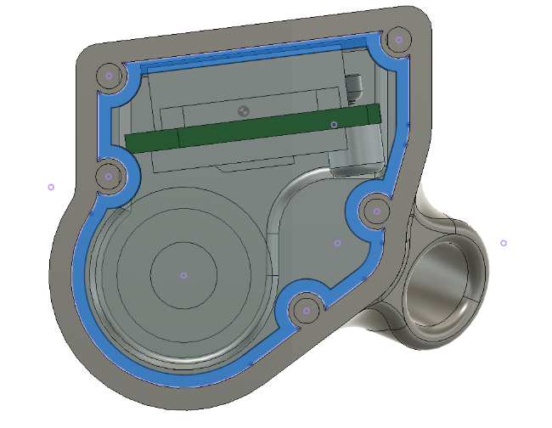**Clean gasket surfaces** of both 3D printed parts with IPA to ensure a tight seal. Let dry.

Sealing gasket surface highlighted in blue

1. **Apply a thin, uniform and continuous bead** of silicone sealant to the gasket surface on the Case side.
2. **Insert antenna wire** through its hole until there is ½ inch of space before closing the case, and apply a thin bead of silicone sealant around the base.

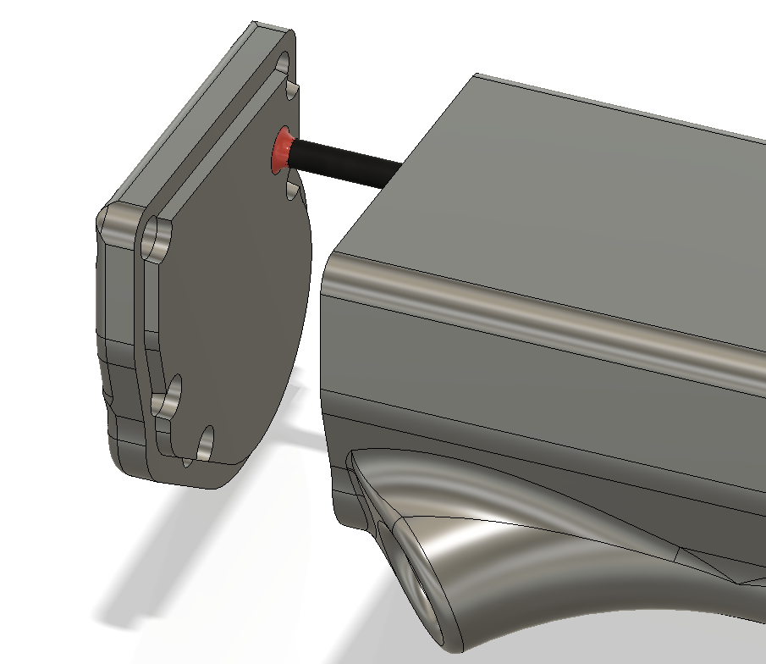

Sealant here is highlighted in Red around the antenna wire

1. **Close the case** gently, and apply additional silicone sealant around the antenna wire. Wipe away excess sealant.
2. **Apply a thin layer of silicone sealant** around the screw holes as highlighted in Step 5.
3. **Insert 5 plastite screws** and uniformly tighten them. Overtightening could lead to stripped screw bosses.
4. **Wipe away** any silicone sealant that oozed out from the screw holes or sealing flange.

The device should now be ready for dispatch.